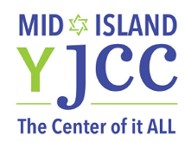
The 2nd Annual Living Memories Project Conference
New Trends and Clinical Intervention in Grief and Bereavement Counseling

Friday January 12, 2018
8:30am to 1:45pm
Mid-Island Y JCC
Plainview, NY
Breakfast Sponsor…………………………………………… $600.00
Exhibitor………………………………………………………... $350.00
Non- Profit Exhibitor……………………………………………$250.00
Includes: Six-foot display table with seating for two representatives admission to conference and breakfast.

Name of Organization: ________________________________________________________________________

Address: ___________________________________________________________________________________

Name of Contact: ______________________________ Title: ________________________________________

Phone Number: _______________________________ Email address: ________________________________
Please include payment with your registration. Tables will be assigned in order of reservation. All fees are non-refundable.

Please make checks payable to: JASA
Mail Registration form with payment to
JASA Partners in Dignity
c/o Mid-Island Y JCC
45 Manetto Hill Road
Plainview, NY 11803

For more information, contact:
Lori Hardoon, LCSW 347-547-7127 lhardoon@jasa.org

